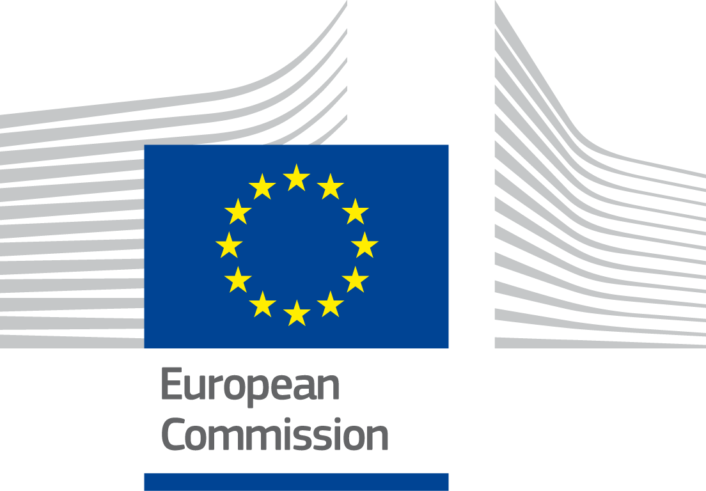

***ISA2***

Digital Public Administration factsheet 2021

Slovakia



Table of Contents

1 Country Profile 4

2 Digital Public Administration Highlights 10

3 Digital Public Administration Political Communications 12

4 Digital Public Administration Legislation 19

5 Digital Public Administration Governance 26

6 Digital Public Administration Infrastructure 34

7 Cross-border Digital Public Administration Services 41

*Please note that the data collection exercise for the update of the 2021 edition of the Digital Public Administration factsheets took place between March and June 2021. Therefore, the information contained in this document reflects this specific timeframe*.



Country

Profile

1

# Country Profile

## Basic data

**Population**: 5 458 827 inhabitants (2020)

**GDP at market prices**: 91 555.3 (2020)

**GDP per inhabitant in PPS (Purchasing Power Standard EU 27=100)**: 71 (2020)

**GDP growth rate**: -4.8 % (2020)

**Inflation rate**: 2 % (2020)

**Unemployment rate:** 6.7 % (2020)

**General government gross debt (Percentage of GDP)**: 60.6 (2020)

**General government deficit/surplus (Percentage of GDP)**: -6.2 (2020)

**Area**: 49 036 km²

**Capital city**: Bratislava

**Official EU language**: Slovak

**Currency**: Euro (EUR)

Source: [Eurostat](https://ec.europa.eu/eurostat/data/database) (last update: 19 July 2021)

## Digital Public Administration Indicators

The following graphs present data for the latest Digital Public Administration Indicators for Slovakia compared to the EU average. Statistical indicators in this section reflect those of [Eurostat](https://ec.europa.eu/eurostat/data/database) at the time the factsheet is being prepared.

|  |  |
| --- | --- |
| Percentage of individuals using the internet for interacting with public authorities in Slovakia | Percentage of individuals using the internet for obtaining information from public authorities in Slovakia |
|  |  |
| Source: [Eurostat Information Society Indicators](http://appsso.eurostat.ec.europa.eu/nui/show.do?dataset=isoc_bde15ei&lang=en) | Source: [Eurostat Information Society Indicators](http://appsso.eurostat.ec.europa.eu/nui/submitViewTableAction.do) |
|  |  |
| Percentage of individuals using the internet for downloading official forms from public authorities in Slovakia | Percentage of individuals using the internet for sending filled forms to public authorities in Slovakia |
|  |  |
| Source: [Eurostat Information Society Indicators](http://appsso.eurostat.ec.europa.eu/nui/submitViewTableAction.do) | Source: [Eurostat Information Society Indicators](http://appsso.eurostat.ec.europa.eu/nui/submitViewTableAction.do) |

## Interoperability State of Play

In 2017, the European Commission published the [European Interoperability Framework](https://ec.europa.eu/isa2/sites/isa/files/eif_brochure_final.pdf) (EIF) to give specific guidance on how to set up interoperable digital public services through a set of 47 recommendations. The picture below represents the three pillars of the EIF around which the EIF Monitoring Mechanism was built to evaluate the level of implementation of the EIF within the Member States. It is based on a set of 71 Key Performance Indicators (KPIs) clustered within the three main pillars of the EIF (Principles, Layers and Conceptual model), outlined below.

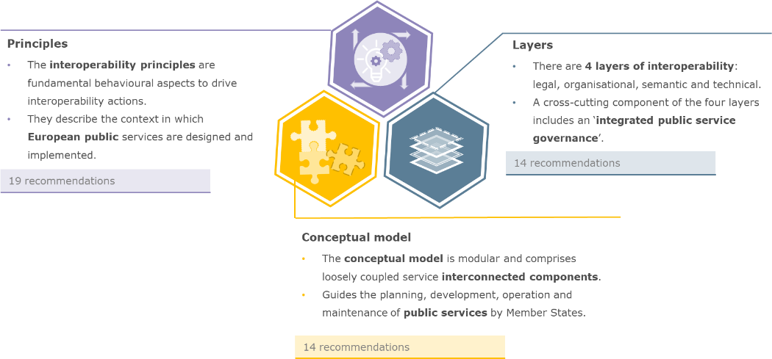

Source: European Interoperability Framework Monitoring Mechanism 2020

For each of the three pillars, a different scoreboard was created to breakdown the results into their main components (i.e. the 12 principles of interoperability, the interoperability layers and the components of the conceptual model). The thematic areas are evaluated on a scale from one to four, where one means a lower level of implementation and 4 means a higher level of implementation. The graphs below show the result of the second EIF Monitoring Mechanism data collection exercise for Slovakia in 2020.

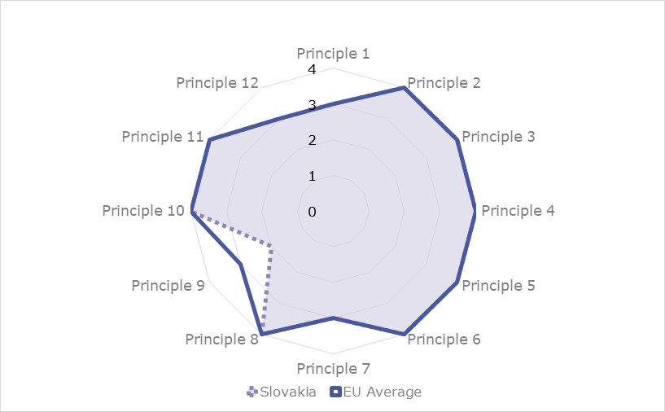

Source: European Interoperability Framework Monitoring Mechanism 2020

Slovakia’s results in Scoreboard 1 show an overall good implementation of the EIF principles. Slovakia meets the European average for every principle, except for Principle 9 (Multilingualism) which obtains a score of 2. The lower-middle performance on this principle indicates that Slovakian public administrations could improve their use of information systems and technical architectures that cater for multilingualism when establishing a European public service. More specifically, the number of language resources and the extent to which public services are broadly available in official EU languages broadly understood by the largest possible number of cross-border users could be improved.

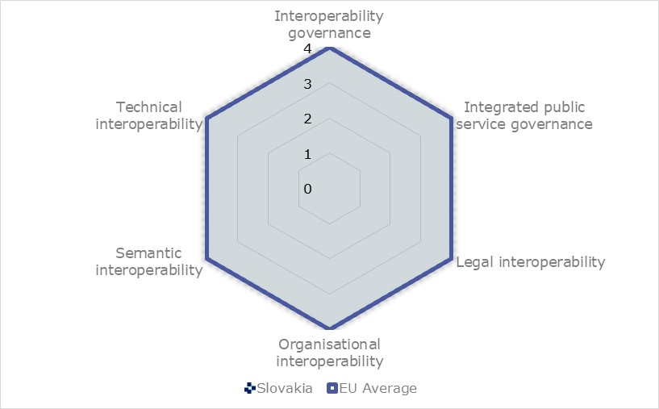

Source: European Interoperability Framework Monitoring Mechanism 2020

The Slovakian results for the implementation of interoperability layers assessed for Scoreboard 2 shows a very good performance. Slovakia reaches a maximum score of 4, in line with the European average, for all interoperability layers. To maintain this high performance, an area of improvement linked to interoperability governance could be for Slovak public administrations to participate more actively in the standardisation work relevant to the needs of all national public administrations to ensure that their requirements are met (Recommendation 24).

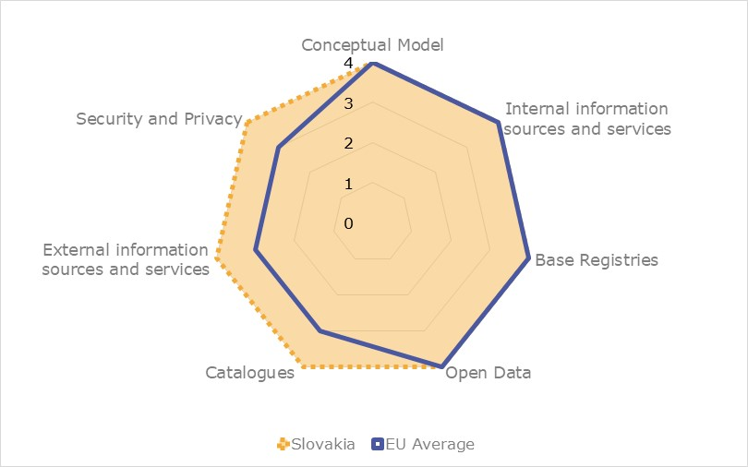

Source: European Interoperability Framework Monitoring Mechanism 2020

Slovakia’s scores assessing the Conceptual Model in Scoreboard 3 show a very good performance in the implementation of all recommendations. In line with the European average, Slovakia gets a maximal score of 4 for open data, base registries, internal information sources and services and Conceptual Model. Slovakia also obtains a score of 4, surpassing the European average for catalogues, external information sources and services, and security and privacy. The high performance in external and information sources and services, for instance, indicates that Slovak public administrations are effectively using external information sources and services while developing public services. In order to maintain the score of 4 in security and privacy, Slovakia could improve its implementation of the Recommendation 47 on the use of trust services according to the Regulation on eID and Trust Services as mechanisms that ensure secure and protected data exchange in public services.

Additional information on Slovakia’s results on the EIF Monitoring Mechanism is available online through [interactive dashboards](https://joinup.ec.europa.eu/collection/nifo-national-interoperability-framework-observatory/eif-monitoring).

## eGovernment State of Play

The graph below presents the main highlights of the latest eGovernment Benchmark Report, an assessment of eGovernment services in 36 countries: the 27 European Union Member States, as well as Iceland, Norway, Montenegro, the Republic of Serbia, Switzerland, Turkey, the United Kingdom, Albania and Macedonia (referred to as the EU27+).

The study evaluates online public services on four dimensions:

* **User centricity**: indicates the extent to which a service is provided online, its mobile friendliness and its usability (in terms of available online support and feedback mechanisms).
* **Transparency**: indicates the extent to which governments are transparent about (i) the process of service delivery, (ii) policy making and digital service design processes and (iii) the personal data processed in public services.
* **Cross-border services**: indicates the extent to which users of public services from another European country can use the online services.
* **Key enablers**: indicates the extent to which technical and organizational pre-conditions for eGovernment service provision are in place, such as electronic identification and authentic sources.

The 2021 report presents the biennial results, achieved over the past two years of measurement of all eight life events used to measure the above-mentioned key dimensions. More specifically, these life events are divided between six ‘Citizen life events’ (Career, Studying, Family life, measured in 2020, and Starting a small claim procedure, Moving, Owning a car, all measured in 2019) and two ‘Business life events’ (Business start-up, measured in 2020, and Regular business operations, measured in 2019).

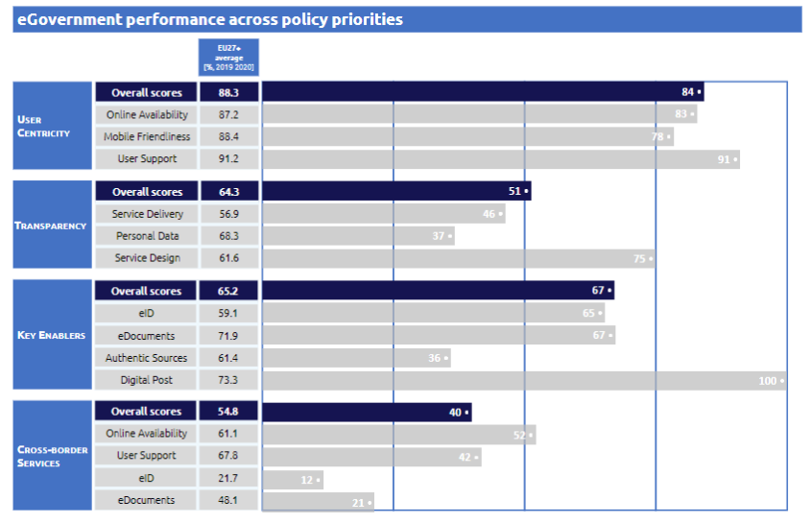

Source: [eGovernment Benchmark Report 2021 Country Factsheets](https://digital-strategy.ec.europa.eu/en/library/egovernment-benchmark-2021)



Digital Public Administration Highlights

2

# Digital Public Administration Highlights

Digital Public Administration Political Communications

The [National Cybersecurity Strategy 2021-2025](https://www.nbu.gov.sk/wp-content/uploads/kyberneticka-bezpecnost/Narodna-strategia-kybernetickej-bezpecnosti.pdf) was prepared by the National Security Authority of the Slovak Republic and it takes into account principles listed in the Slovak [Security Strategy](https://www.mosr.sk/bezpecnostna-strategia-sr/) and strategies of the EU, NATO, OECD and UN. Building on the cybersecurity strategy that covered the period of 2015-2020, the strategic goals aim to serve the interests of the state and protect the services provided to citizens and businesses.

Digital Public Administration Legislation

As of 1 May 2019, a [new Act No. 95/2019](https://www.slov-lex.sk/pravne-predpisy/SK/ZZ/2019/95/20210101.html) on Information Technologies in Public Sector entered into force replacing former Act 275/2006 on information systems in public administration. The new Act brought a systemic change in the management of IT in the public sector. Respective public bodies charged with the IT management were given more responsibilities within the whole project cycle of IT implementation – planning, procurement, implementation, monitoring and evaluation. The Ministry of Investments, Regional Development and Informatisation of the Slovak Republic has started the preparation of the executive regulations to this Act.

Digital Public Administration Governance

In July 2020, the Deputy Prime Minister Office for Investments, Regional Development and Informatisation of the Slovak Republic has been transformed into the [Ministry of Investments, Regional Development and Informatisation of the Slovak Republic.](https://www.mirri.gov.sk/en/index.html) The main tasks of the Ministry among others are to create and implement a uniform state policy towards EU funds, to perform tasks that stem from the membership of the Slovak Republic in international organisations, to be an intermediary body for management of the Operational Programme ‘Integrated Infrastructure’ (OPII), Priority Axis 7 and the Digital Single Market policy’ (OPII), Priority Axis 7 and the Digital Single Market policy.

Digital Public Administration Infrastructure

Since December 2020, the government portal slovensko.sk serves also as a Single Digital Gateway according to the [Regulation No 2018/1724](https://eur-lex.europa.eu/legal-content/EN/TXT/?uri=uriserv:OJ.L_.2018.295.01.0001.01.ENG). It contains the information part in Slovak and in English language, which can be found in the ‘Life events’ section. Currently, the information content is continuously updated according to legislative changes and reports of individual ministries (coordinators). Life events’ section. Currently, the information content is continuously updated according to legislative changes and reports of individual ministries (coordinators).

In the third quarter of 2020, the Ministry of Investment, Regional Development and Informatization of the Slovak Republic in cooperation with the Ministry of Economy of the Slovak Republic prepared a national competition for the selection of European Centers for Digital Innovation (ECDI). During April and May 2021, a second round of competition started.

In 2020, the Ministry of Investment, Regional Development and Informatization of the Slovak Republic joined the [National Coalition for Digital Skills and Jobs](https://digitalnakoalicia.sk/) of the Slovak Republic, established at the initiative of the European Commission. Its goal is to mobilize across the spectrum of public, private, academic and civic organizations and institutions in Slovakia to improve the digital skills of citizens, IT specialists, all employees and in education.



Digital Public Administration Political Communications

3

# Digital Public Administration Political Communications

## Specific political communications on digital public administration

Berlin Declaration on Digital Society and Value-Based Digital Government

In December 2020, the Slovak government signed the Berlin Declaration on Digital Society and Value-Based Digital Government, thus re-affirming its commitment – together with other EU Member States – to foster digital transformation in order to allow citizens and businesses to harness the benefits and opportunities offered by modern digital technologies. The Declaration aims to contribute to a value-based digital transformation by addressing and strengthening digital participation and digital inclusion in European societies.

2030 Strategy for the Digital Transformation of Slovakia

The [2030 Strategy for the Digital Transformation of Slovakia](https://www.vicepremier.gov.sk/wp-content/uploads/2019/10/SDT-English-Version-FINAL.pdf) framed the government strategy in a way that defined national policies and particular priorities with regard to the ongoing digital transformation of the economy and society.

The strategy followed up on the priorities of the EU Digital Single Market. At the national level, it accelerated ongoing processes in terms of building the digital market and carrying out various measures that arose from the most recent cross-sectoral policies of the EU. The strategy also reflected the strategic materials and recommendations of international organisations (EU, OECD, UN, G7 and G20) that consider digital transformation to be the key to inclusive and sustainable growth. The strategy puts emphasis on new digital technologies such as artificial intelligence, Internet of Things, 5G technology, big data and analytical processing of data, blockchain or high-performance computers, which will eventually become a new engine of economic growth and competitiveness.

Several areas were identified regarding the necessity to multiply the potential of digital transformation:

* Economy;
* Society and education;
* Public services;
* Rural development; and
* Science, research and innovation.

The targets of the process are the citizens, whose everyday life should get simpler, and entrepreneurs, whose businesses should be supported by various incentives and whose bureaucratic burdens should be eliminated.

The strategy was followed by the 2019-2022 [Action Plan for the Digital Transformation of Slovakia,](https://www.vicepremier.gov.sk/wp-content/uploads/2019/10/AP-DT-English-Version-FINAL.pdf) which defines particular measures in several priority areas:

* Improvement of education and fostering digital skills and employment for the modern era;
* Creation of a basis for a modern digital economy;
* Improvement of the ability of public services to innovate and use data; and
* Development and practical implementation of artificial intelligence.

As for the digital government, the ambition is to launch and implement a “data-driven State” concept in the public administration. The aim of the concept is for public administration to adopt decisions based on its best available knowledge. It is necessary to make sure that the institutions know how to use real data and make data-based (and possibly automated) decisions. Transforming the functioning of public administration organisations and processes is also key, so that such analyses can be effectively used. The action plan also proposes the continuous deployment of fully automated public administration services. This would imply that the system would handle filings automatically based on selected criteria.

2015-2020 National eGovernment Concept

The [National eGovernment Concept](https://www.mirri.gov.sk/sekcie/narodna-koncepcia-informatizacie-verejnej-spravy-nikvs/index.html), which was approved by the Slovak government in September 2016, defined the strategic Enterprise Architecture of eGovernment and its central coordination, and also the principles and objectives of further development in accordance with the goals stated in the [Strategic Document for Digital Growth and Next Generation Access Infrastructure](https://www.mirri.gov.sk/wp-content/uploads/2019/04/Strategicky_dokument_2014_2020_SK.pdf). This document represented a new approach to informatisation with special emphasis on achieving openness, fair competition, and increasing the value of IT in key functions of public administration, whether through improved services, better data-based decisions, better regulation, or more efficient operation. This document represented a new approach to informatisation with special emphasis on achieving openness, fair competition, and increasing the value of IT in key functions of public administration, whether through improved services, better data-based decisions, better regulation, or more efficient operation. This strategy will be soon replaced by the new National eGovernment Concept.

National eGovernment Concept 2030

The work on the new National eGovernment Concept 2030 started in the second half of 2020 and it is estimated to be published in Q3 of 2021. The National eGovernment Concept 2030 will follow these strategic documents: the [2030 Vision and Strategy for Development of Slovakia](https://www.mirri.gov.sk/wp-content/uploads/2021/01/Slovensko-2030.pdf), the [2030 Digital Transformation Strategy of Slovakia](https://www.mirri.gov.sk/wp-content/uploads/2019/10/SDT-English-Version-FINAL.pdf), the [National Cybersecurity Strategy 2021–2025](https://www.nbu.gov.sk/wp-content/uploads/cyber-security/National_cybersecurity_strategy_2021.pdf), and the [National Plan for Broadband Connection](https://rokovania.gov.sk/RVL/Material/25814/1). It will contain three strategic targets: digital services (truly digital services; digital officers; one State, one design, one place), digital transformation (a fundamental change of how public services work; better data; informatisation of local government) and effective governance of the digital State (centralisation where it makes sense; cyber and information security; public procurement and purchasing; human resources in State IT; effective management). Every strategic target will be regularly evaluated based on indicators.

The National eGovernment Concept 2030 concerns all elements of public administration. It formulates a set of strategic goals, priorities and measures which aim is to create a central architecture at the national level and to define policy, regulatory and other tools in order to build a controlled and effective level of informatisation in public administration. It also contains a new systemic plan for the preparation and implementation of the intended goals.

2014-2020 Operational Programme ‘Integrated Infrastructure’

The [Operational Programme ‘Integrated Infrastructure’ (OPII)](https://www.opii.gov.sk/) is a strategic document developed for the absorption of EU funds in the transport sector and in the area of enhancing access, use and quality of information technologies. The overall focus of the OPII, its specific objectives and activities were set to ensure the fulfilment of the Europe 2020 Strategy priorities and the National Reform Programme of the Slovak Republic.

The overall objective of the OPII was to support sustainable mobility, economic growth, job creation while improving the business climate through the development of transport infrastructure, public transport and information society.

The Ministry of Investments, Regional Development and Informatisation of the Slovak Republic is responsible for the area of information society within the Operational Programme ‘Integrated Infrastructure’. Other objectives of the operational programme were managed by the Ministry of Transport, Construction and Regional Development to support sustainable mobility, economic growth, job creation and improve the business environment through the development of transport infrastructure.

The Ministry of Investments, Regional Development and Informatisation of the Slovak Republic acts as an intermediary body responsible for Priority Axis 7 - Information Society. The funds were invested in the development of electronic services for citizens and businesses, suited to complex life events and cross-border interoperability, and aimed at increasing the availability of government data through open data. At the same time, the public administration reform was supported by ICT, including the further expansion of the government cloud. Finally, the allocation for Priority Axis 7 should ensure coverage of all households with broadband internet at a minimum speed of 30 mbps.

This document has been adopted for 2014-2020, but thanks to the ‘n + 3’ rule for project implementation, it is possible to implement OPII projects until the end of 2023.As a consequence, the actual duration of this program is until 2023. As a follow up document for years 2021-2027, a new programme, called ‘[Operational Program Slovakia](https://rokovania.gov.sk/RVL/Material/25931/1)’, is under preparation. Its adoption is foreseen in the first half of 2022.

Strategic Document for Digital Growth and Next Generation Access Infrastructure (2014–2020)

The [Strategic Document for Digital Growth and Next Generation Access Infrastructure (2014-2020)](https://www.vicepremier.gov.sk/wp-content/uploads/2019/04/Strategicky_dokument_2014_2020_EN.pdf) defined a strategy for the development of digital services and next generation access infrastructure in Slovakia. It focused on the fulfilment of the ex-ante conditionalities by means of which the EU evaluated the readiness of Member States to implement investment priorities of their choice. In particular, the document deals with information access, use and quality and communication technologies. The document is [evaluated annually](https://www.opii.gov.sk/monitorovanie-a-hodnotenie/hodnotiace-spravy) within the Operational Programme ‘Integrated Infrastructure’.

The strategy aimed to further develop digital infrastructure services and next generation networks in Slovakia for the 2014-2020 period. These could be summarised in the following eGovernment investment priorities emphasised in the 2014-2020 period:

* Services for citizens and businesses;
* Effective public administration; and
* Broadband/Next Generation Network.

The document served as a basis for the preparation of the [Operational Programme ‘Integrated Infrastructure](https://www.vicepremier.gov.sk/projekty/projekty-esif/operacny-program-integrovana-infrastruktura/prioritna-os-7-informacna-spolocnost/projekty/index.html)’ (Priority Axis - Information Society) for the 2014-2020 period.

The document was approved by the government of the Slovak Republic on 8 January 2014. A new version of this document for 2021-2027 is currently under preparation.

Proposal for the ESIF Programming Period 2021–2027

Negotiations for the new programming period began in early 2020. The Ministry of Investments, Regional Development and Informatisation of the Slovak Republic proposed a follow-up strategy based on the current investments. The strategy had a higher focus on reducing bureaucracy for businesses and citizens, and the objective of speeding up the digital take-up with digital-by-default services. Moreover, it can be used to support data-driven governance, with more public sector data available, building the digital government structure as a platform based on open APIs. It will also increase the quality of public services thanks to continued feedback from the users.

The [partnership agreement proposal](https://www.mirri.gov.sk/wp-content/uploads/2020/12/Ozn%C3%A1menie-Partnersk%C3%A1-dohoda-n%C3%A1vrh_final4.pdf) released in December of 2020 includes policy objectives aligned with the government digitalisation through the development of the digital and data economy, the modernisation of public services, and the creation of smart regions and cities.

## Interoperability

New National eGovernment Concept 2030

The New National eGovernment Concept 2030, which is currently under preparation, contains the strategy for achieving interoperability of public administration services in Slovakia (e.g. data interoperability of information systems, semantic data interoperability, interoperability of publicly available open data from base registries published at the central portal of open data, interoperability of base registries, and interoperability of government cloud).

## Key enablers

### Access to public information

Action Plan for the Open Governance Initiative

The [Action Plan](https://datalab.digital/wp-content/uploads/AP-OGP-2020-2021_material.pdf) for the Open Governance Initiative in the Slovak Republic for the years 2020-2021 has been approved by Resolution of the Government of the Slovak Republic No. 553/2019. Its aim is to give access to data owned by the State in a machine-readable format licensed for further use.

### eID and Trust Services

New National eGovernment Concept 2030

The New National eGovernment Concept 2030, which is currently under preparation, operates with the concept of eID as one of the key enablers for government services.

### Security aspects

National Cybersecurity Strategy 2021-2025

The [National Cybersecurity Strategy for 2021-2025](https://www.nbu.gov.sk/wp-content/uploads/kyberneticka-bezpecnost/Narodna-strategia-kybernetickej-bezpecnosti.pdf) was approved by the government in January 2021. It was prepared by the National Security Authority of the Slovak Republic and it takes into account the principles listed in the [Security Strategy](https://www.mosr.sk/bezpecnostna-strategia-sr/) and EU, NATO, OECD and UN strategies. Building on the cybersecurity strategy for the period 2015-2020, the strategic goals aim to serve the interests of the State and protect the services provided to citizens and businesses. Six principles are defined for the cybersecurity system:

* The primacy of fundamental human rights and freedom in the cyberspace;
* Legal-based cybersecurity in the management system and mechanisms of the security system;
* A comprehensive and universal approach to cybersecurity;
* Risk management as a key element of the national cybersecurity management system;
* Support, cooperation and prevention; and
* Continuous capacity building in the field of the cybersecurity.

The [national cybersecurity strategy for 2021-2025](https://www.nbu.gov.sk/wp-content/uploads/kyberneticka-bezpecnost/Narodna-strategia-kybernetickej-bezpecnosti.pdf) pursues seven high-level (strategic) goals:

1. A reliable State prepared for threats;

2. Effective detection and clarification of cybercrime;

3. A resilient private sector;

4. Cyber security as an essential part of public administration;

5. Strong partnerships;

6. Educated professionals and an educated public; and

7. Research and development in the field of cyber security.

The Action Plan for the implementation of the National Cybersecurity Strategy for 2021-2025 is under preparation and is foreseen to be released in May/June 2021.

### Interconnection of base registries

New National eGovernment Concept 2030

One of the aims of the New National eGovernment Concept 2030, which is currently under preparation, is to achieve the interconnection of public administration information systems and reference registers. The efficient interconnection of systems will allow to merge related services while minimising user interactions or the need for manual data entry.

### eProcurement

IT Procurement in the Public Administration

In May 2019, the Council for Digitalisation and the Digital Single Market of the Government of the Slovak Republic adopted the [Concept for IT Procurement](https://sp.vicepremier.gov.sk/verejne-obstaravanie-IKT/Verejn/2019_05_16_Koncepcia_nakupu_IT_s%20prilohami_schvalene_znenie.pdf) in the Public Administration. This concept is the result of the multi-stakeholder working group on ICT public procurement.

## Domain-specific political communications

Proposal for the Centralisation and Development of Data Centres in the State Administration

The Government of the Slovak Republic approved a [Data Centre Strategy](https://www.vicepremier.gov.sk/en/sections/informatization/egovernment/strategic-documents/the-proposal-for-the-centralisation-and-development-of-data-centers/index.html), whose main goal was to centralise the number of data centres of the State into just two facilities, under the scope of the Ministry of Finance and the Ministry of the Interior in 2014. The cloud services in the scope included, for example, IaaS, PaaS, SaaS, and benefited from high levels of quality and safety in the form of catalogue services.

A new National eGovernment Concept 2030 is currently being prepared. It will also include a section on data centres and replace this strategy.

Implementation Plan of the Research and Innovation Strategy for Smart Specialisation of the Slovak Republic (‘RIS3 IP’)

This implementation plan contains procedures and processes which need to be carried out in order to fulfil missing criteria in relation to thematic ex ante conditionality 1.1 for thematic objective 1. Strengthening research, technological development and innovation and implementation of relevant investment priorities funded in the 2014-2020 programming period as well as measures to which the Slovak Republic committed itself in the Operational Program ‘Research and Innovation’. Three basic areas of specialisation were approved, which were transformed into 5 intelligent specialisation domains (one of them being ‘Digital Slovakia’).

National Strategy and Action Plan to Improve the Position of Slovakia in the Digital Economy and Society Index

In May 2021, the government of the Slovak Republic approved the [National Strategy and Action Plan to improve the position of Slovakia in the Digital Economy and Society Index (DESI](https://www.slov-lex.sk/legislativne-procesy/-/SK/LP/2021/126/pripomienky/zobraz)), whose aim is to bring the country up to speed with the European digital economy level. It sets targets for each of the indicators measured in the DESI (connectivity, human capital, use of internet by citizens, integration of digital technology by businesses, digital public services).

## Emerging Technologies

New Technologies Identified by the 2030 Digital Transformation Strategy of Slovakia

The [2030 Digital Transformation Strategy of Slovakia](https://www.vicepremier.gov.sk/wp-content/uploads/2019/10/SDT-English-Version-FINAL.pdf) identifies several key technologies and technological areas that need to be supported by the government:

* Artificial Intelligence and blockchain, which are key to use the most revolutionary current technologies and find enough use for them (in view of exporting services);
* Data and privacy protection, necessary for creating a functioning base for a vibrant data economy where consumer rights are safeguarded;
* High-performance computing; getting access to high-performance computing and storage capacity that also efficiently uses resources is the cornerstone of success in the digital era. The age of quantum technologies is approaching – quantum computers, quantum cryptography and quantum sensors as part of the IoT will become the decisive technologies in the new IT age;
* Next-generation fixed and mobile networks will allow Slovakia to get access to high-speed broadband connection, extension of NGA technologies in order to transfer data quickly and seamlessly. Subsequently, it will be necessary to build 5G networks to support autonomous and connected mobility and smart transport systems with expected massive utilisation in the future; and
* Internet of Things (IoT), in particular in the context of education. In fact, various primary and secondary school and university curricula in Slovakia have already been extended with matters concerning IoT, thanks to which Slovak students have excellent results in IoT and robotics.

In order to carry out effective measures in the mentioned priority areas, it is necessary to strengthen the institutional background that constitutes the basis of the innovation ecosystem. The [2019-2022 Action Plan for Digital Transformation of Slovakia](https://www.vicepremier.gov.sk/wp-content/uploads/2019/10/AP-DT-English-Version-FINAL.pdf) defines the ambition to create and strengthen the current institutional background in order to bring the benefits of novel technologies across all economic and societal sectors. This could be achieved by supporting the set-up of the different areas in order to facilitate its uptake. The possible measures include:

* Support to activities of the Digital Coalition;
* Support to setting up and connecting DIHs in Slovakia;
* Support to setting up and operating a platform for research on and use of Artificial Intelligence;
* Support to setting up and operating the platform for research on and use of the blockchain technology;
* Support to setting up and operating a national high-performance computing competence centre; and
* Support to setting up and operating the national competence and coordination centre for cybersecurity.



Digital Public Administration Legislation

4

# Digital Public Administration Legislation

## Specific legislation on digital public administration

Information Technologies in the Public Sector Act No. 95/2019

The [Information Technologies in the Public Sector Act No. 95/2019](https://www.slov-lex.sk/pravne-predpisy/SK/ZZ/2019/95/20210101.html) came into force on 1 May 2019. This legislation replaced the previous Act No. 275/2006 and introduced a systemic change in the management of IT in the public administration by regulating the complete lifecycle of IT governance. It also extended the scope of obligations for public institutions responsible for IT management when it comes to IT planning, procurement, implementation, monitoring and evaluation.

In addition, the Act also facilitated the cost decrease in IT procurement by setting more favourable licence conditions for the procurement of unique software solutions. The new Act also reflects the changes brought by technological developments and global trends, which must be taken into account in order to fulfil the expectations of citizens. Finally, the Act also introduces a control mechanism to ensure that the obligations are fulfilled and offer feedback on the progress of IT management.

Act No. 305/2013 on eGovernment

The Parliament adopted [Act No. 305/2013 on eGovernment](https://www.slov-lex.sk/pravne-predpisy/SK/ZZ/2013/305/20201230.html), laying down the basic principles upon which a future electronic public administration will operate. The Act did not replace traditional paper procedures from the official agenda, but it created a comprehensive electronic alternative. It also described a number of key elements, such as pursuance by proxy, basic registries, eDesk modules document conversion, electronic payment of fees, and authentication of persons in public administration information systems, eDelivery, eForms, electronic personal mailbox, the administration and operation of a central portal for public administration and Integrated Service Points (ISPs) for assisted public administration eServices. Furthermore, it also laid the foundation for a common data layer by defining a common central module for intergovernmental communication. This module implemented the rules and processes for data exchange among IT systems from different segments (see 4.2.4 Interconnection of base registries) and applied the concepts of Master Data Management.

Amendment No. 211/2019 to Act No. 305/2013 on eGovernment

The [latest amendment](https://www.slov-lex.sk/pravne-predpisy/SK/ZZ/2019/211/20200701) to the eGovernment Act entered into force on 1 August 2019. The legislation introduced changes in the area of authentication and completed the identification schemes published according to [Regulation (EU) No. 910/2014 of the European Parliament and of the Council of 23 July 2014 on electronic identification and trust services for electronic transactions in the internal market](https://eur-lex.europa.eu/legal-content/EN/TXT/?uri=CELEX%3A32014R0910), repealing Directive 1999/93/EC. The amendment also allowed to start the failed delivery process even without the appeal of the addressee, in case the administrator of the electronic mailbox notifies objective technical issues with the delivery.

The use of OpenAPI for publishing the tools for electronic filing was made obligatory and eID, as well as registry data, can now be used by private sector entities in more cases. Therefore, the private sector can obtain clients’ data (with their consent) from the registry of natural persons, and authenticate their identity via eID in the same way as the eGovernment services do. Finally, another significant change was introduced with the opportunity to set up an electronic mailbox for minors under 18 years of age.

Decree No. 179/2020 Laying down the Method of Categorisation and the Content of Security Measures for Public Administration Information Technologies

[The decree](https://www.slov-lex.sk/pravne-predpisy/SK/ZZ/2020/179/) provides categories of public administration information technologies and details on the method of classification into these categories using the classification of information and the categorisation of networks and information systems according to a special regulation. It also defined the security of public administration information technologies, the content of security measures, the content and structure of the security project and the scope of security measures depending on the classification of information and the categorisation of networks and information systems.

## Interoperability

Act against Bureaucracy No. 177/2018

[Act No. 177/2018](https://www.slov-lex.sk/pravne-predpisy/SK/ZZ/2018/177/20210101.html) on measures to reduce the administrative burden by using public administration information systems, and on the amendments and supplements to certain acts (Act against Bureaucracy) came into force on 1 September 2018. According to the provisions of Par. 1 of the Act, in the performance of their official activities, public authorities are obliged and authorised to obtain and use data stored in public administration information systems to produce extracts, and to provide such data and extracts when necessary.

Moreover, an amendment to the Act against Bureaucracy No. 177/2018 eliminated the need for citizens to provide 11 types of paper documents in their dealings with the authorities.

The amendment to the Act against Bureaucracy (14 April 2019) relieved citizens and companies of their duty to submit further statements and confirmations by using the public administration information system. The removal of administrative burdens and the simplified processes related to the confirmation of arrears within social insurance, as well as health insurance calculations, confirmation of school visits, and extracts from the register of NGOs.

In December 2019, the government of the Slovak Republic adopted the second amendment to Act No. 177/2018. Following the amendment, the list of documents that citizens and businesses had to obtain and deliver to public authorities within their proceedings was further reduced by eight.

The adoption of the amendment will enhance the automatisation of the processes and pro-active services of the State. The data automatically retrieved by public authorities from the available registries include birth, marriage and death certificates, confirmations of address change, certificates stating the existence of a business subject, certificates proving a business is not in liquidation or bankrupt or that it does not employ workers illegally.

Act on Data

Currently, a legislative process in under way on a new proposal for an Act on Data, which aims is to help transform Slovakia into a State that makes its decisions on the basis of expert data from analyses, predictions and evaluations using current, available, accurate and complete data. To this end, the draft law contains an amendment to the rights of natural persons and legal entities and the obligations of public authorities in the handling of data on natural persons and legal entities and in the processing thereof.

## Key enablers

### Access to public information

Act on Free Access to Public Information No. 211/2000

The [Act on Free Access to Information](https://www.slov-lex.sk/pravne-predpisy/SK/ZZ/2000/211/20210101.html), which came into force on 1 January 2001, defined the term ‘public information’ and established a general principle of free and unlimited access. Under the Act, any person or organisation can request information held by State agencies, municipalities and private organisations that make public decisions. The body has to respond no later than 10 days after receipt of the request and keep a registry of requests. Costs are limited to reproduction and can be waived. There are a number of exemptions (e.g. for information classified as a State or professional secret, personal information, trade secrets, etc.), which can be withheld. Appeals are made to higher agencies and can be reviewed by a court.

Reuse of Public Sector Information

Slovakia notified the full transposition of [Directive 2003/98/EC of the European Parliament and of the Council of 17 November 2003 on the re-use of public sector information (PSI Directive)](http://eur-lex.europa.eu/LexUriServ/LexUriServ.do?uri=CELEX:32003L0098:EN:HTML). This legislation was implemented by on Free Access to Public Information.

As of 17 July 2021, the [Directive 2003/98/EC of the European Parliament and of the Council of 17 November 2003 on the re-use of public sector information (PSI Directive)](http://eur-lex.europa.eu/LexUriServ/LexUriServ.do?uri=CELEX:32003L0098:EN:HTML) will be replaced by [Directive (EU) 2019/1024 of the European Parliament and of the Council of 20 June 2019 on open data and the re-use of public sector information](https://eur-lex.europa.eu/legal-content/EN/TXT/?uri=uriserv:OJ.L_.2019.172.01.0056.01.ENG). This Directive will be transposed by the amendment to [Act No. 211/2000 on Free Access to Public Information](https://www.slov-lex.sk/pravne-predpisy/SK/ZZ/2000/211/).

### eID and Trust Services

eSignatures

[Act No. 215/2002 on Electronic Signatures](https://www.slov-lex.sk/pravne-predpisy/SK/ZZ/2002/215/20160701.html) was repealed by [Act No. 272/2016 on Trust Services for Electronic Transactions in the Internal Market](https://www.slov-lex.sk/pravne-predpisy/SK/ZZ/2016/272/20190801.html) based on [Regulation No. 910/2014](http://eur-lex.europa.eu/legal-content/EN/TXT/?uri=uriserv%3AOJ.L_.2014.257.01.0073.01.ENG) of the European Parliament and of the Council of 23 July 2014 on electronic identification and trust services for electronic transactions in the internal market. It regulates the relations arising in connection with the creation and use of electronic signatures and electronic seals, the rights and obligations of persons and legal persons when using electronic signatures and electronic seals, and the reliability and protection of electronic documents signed by electronic signatures or provided with electronic seals.

Trust Services

Act No. 272/2016 on Trust Services for Electronic Transactions in the Internal Market and amending certain laws (Trust Services Act) regulates the conditions for the provision of trust services, the obligations of trust service providers, the competence of the National Security Authority in the area of trust services and sanctions for breaches of obligations under a special regulation and this Act.

### Security aspects

Cybersecurity Act

In March 2018, the [Act on Cybersecurity](https://www.slov-lex.sk/pravne-predpisy/SK/ZZ/2018/69/20200701.html) was published in the Collection of Laws as No. 69/2018. This legislation was the first legal norm governing cybersecurity within the Slovak Republic. It came into force on 1 April 2018. The Act establishes minimum security and notification requirements with the aim of providing cybersecurity. It regulates: the jurisdiction of public administration bodies in the area of cybersecurity; the national strategy on cybersecurity; the cybersecurity Single Information System; the status and the obligations of essential services operators and digital service providers; the organisation and the competencies of CIRT units; education and awareness building; and inspection mechanisms and sanctions.

The new Act transposed [EU Directive on network and information security (NIS Directive)](https://eur-lex.europa.eu/eli/dir/2016/1148/oj)into the Slovak legal system.

A draft amendment to the Cybersecurity Act was approved in May 2021. The amendment aims to deal with certain open issues identified in practice since the relatively recent adoption of the statute (Act No. 69/2018 on cybersecurity), most notably the precise extent of operators of essential services within the public services landscape of the Slovak Republic and particular dynamics of direct blocking of harmful content when a security incident takes place, among others.

The bill further aims to amend various other legislation with regards to cybersecurity and public administration IT systems in general, such as the Act on IT in Public Administration. Suggested changes to these other laws are mostly of technical nature, rescinding certain obsolete provisions, unifying the terminology used throughout related legislation to safeguard their smooth application, as well as conformity with applicable EU legislation.

The Cybersecurity Act might be subject to further amendments down the line in order to safeguard compliance with the upcoming NIS2 Directive following the adoption thereof.

Act No. 18/2018 on Personal Data Protection

Act [18/2018](https://www.slov-lex.sk/pravne-predpisy/SK/ZZ/2018/18/20190901.html) implements the General Data Protection Regulation ([2016/679](https://eur-lex.europa.eu/eli/reg/2016/679/oj)) and transposes Directive ([2016/680](https://eur-lex.europa.eu/legal-content/EN/TXT/?uri=CELEX%3A32016L0680)) on the protection of natural persons with regard to the processing of personal data by competent authorities for the purposes of the prevention, investigation, detection or prosecution of criminal offences or the execution of criminal penalties, and to the free movement of such data.

This Act regulates:

* The processing operations which are not within the scope of GDPR;
* The processing of personal data vested in our national legislation by the GDPR;
* The processing of personal data in the law enforcement sector;
* The duties, responsibilities and liabilities in the personal data processing; and
* The scope of the powers and the organisation of the [Office for Personal Data Protection of the Slovak Republic](https://dataprotection.gov.sk/uoou/en).

Act No. 45/2011 on Critical Infrastructure

The [Act on Critical Infrastructure No. 45/2011](https://www.slov-lex.sk/pravne-predpisy/SK/ZZ/2011/45/20210119.html) came into force on 1 March 2011. This legislation implemented Council [Directive 2008/114/EC of 8 December 2008 on the identification and designation of European critical infrastructures and the assessment of the need to improve their protection](http://eur-lex.europa.eu/LexUriServ/LexUriServ.do?uri=OJ:L:2008:345:0075:0082:EN:PDF).

### Interconnection of base registries

Reference Registries Framework in Act No. 305/2013

The basic legislative framework related to the base and reference registries and their mutual interconnection is defined in [Act No. 305/2013 on eGovernment](https://www.slov-lex.sk/pravne-predpisy/SK/ZZ/2013/305/20201230.html). Its sixth part contains basic rules for equating data, referencing and correcting data between the registries, as well as rules on obligations of registries administrators. Specific rules regarding the respective registries, including the extent of their data and the opportunities for other entities to access them for specific purposes, are defined in the regulations which created them. The eGovernment Act also created rules for the establishment of a common central process and data integration module, which:

* Grants unified access to data within the information systems in order to allow public authorities to exercise their duties electronically; and
* Integrates and synchronises data during referencing, and offers a single way of providing data from the information systems of public authorities, mainly from reference registries.

At the end of 2018, Slovakia adopted [Act against Bureaucracy No. 177/2018](https://www.slov-lex.sk/pravne-predpisy/SK/ZZ/2018/177/20210101.html), which introduced the obligation for public authorities to automatically and electronically exchange the data stored in their information systems without requesting data from the citizens or businesses, following the Once-Only principle. The Act is supported by the establishment of the Data Office, which implements the policy and its principles in public sector data management.

The interconnection of registries and the exchange of data between public authorities was supported by the Ministry of Investments, Regional Development and Informatisation of the Slovak Republic through the establishment of [the Data Office](https://datalab.digital/) at the beginning of 2019. The Data Office is responsible for implementing the policy and the principles in public sector data management. It also works towards a central data model by mapping out the relations between the data and the registries. The Data Office also oversees data quality, the publication of reference data, open data, the access to MyData and consolidates an analytical background available for policy making.

### eProcurement

Act on Public Procurement No. 95/2013

[Act No. 95/2013](https://www.slov-lex.sk/pravne-predpisy/SK/ZZ/2013/95/), which entered into force on 1 July 2013, amended [Act No. 25/2006 on Public Procurement](https://www.slov-lex.sk/pravne-predpisy/SK/ZZ/2006/25/20160418.html). This legislation implemented [Directive 2007/66/EC](http://eur-lex.europa.eu/LexUriServ/LexUriServ.do?uri=OJ:L:2007:335:0031:0046:EN:PDF) of the European Parliament. The amendment provided further details on the regulation of review procedures, harmonised the standstill periods applied in the procurement process with the periods laid down in the Directive, and regulated the entire supervision process directly in the Public Procurement Act.

eInvoicing Legislation

In Slovakia, the competent authority for eInvoicing is the [Ministry of Finance](http://www.finance.gov.sk/en/). The eInvoicing platform is under construction and the launch is planned for 2022. The Decree set out that the Ministry of Finance and the Office for Public Procurement are the responsible bodies for the transposition and implementation of [Directive 2014/55/EC](http://eur-lex.europa.eu/legal-content/EN/TXT/?uri=CELEX%3A32014L0055). The Directive was transposed into Act No. 215/2019, which entered into force on 1 August 2019.

## Domain-specific legislation

Act on Electronic Commerce No. 22/2004

The [Act on Electronic Commerce](https://www.slov-lex.sk/pravne-predpisy/SK/ZZ/2004/22/), which came into force on 1 February 2004, regulates the relationships between information society service providers and recipients that may arise when communication takes place remotely, or while electronic devices are connected by means of an electronic communication network. These can be based on electronic processing, transmission, storage, search or collection of data including text, sound and picture, supervision over compliance with this Act, and also international cooperation in electronic commerce.

## Emerging technologies

No legislation has been adopted in this field to date.



Digital Public Administration Governance

5

# Digital Public Administration Governance

## National

### Policy

Ministry of Investments, Regional Development and Informatisation of the Slovak Republic

[The Ministry of Investments, Regional Development and Informatisation of the Slovak Republic](https://www.mirri.gov.sk/en/index.html) (hereinafter the Ministry) is a central public authority body which succeeded the former Deputy Prime Ministers Office for Investments, Regional Development and Informatisation of the Slovak Republic on 1 July 2020. Among the main tasks of the Ministry is the creation and the implementation of a uniform State policy towards EU funds, e.g. in the field of informatisation of society, eGovernment and investments. The Ministry performs tasks that stem from the membership of the Slovak Republic in international organisations, being an intermediary body that manages the Operational Programme ‘Integrated Infrastructure’ (OPII), Priority Axis 7 and the Digital Single Market policy on the national level. The Ministry also provides for the performance of obligations resulting from international treaties and conventions that are binding on the Slovak Republic and fall under the scope of competences of the Ministry - (OPII), Priority Axis 7 and the Digital Single Market policy on the national level.

Within the Ministry of Investments, Regional Development and Informatisation, four divisions perform tasks related to the informatisation of the public administration and the broader digitalisation of society: the Public Administration Information Technologies Division, the Digital Agenda Division, the Cybersecurity Division and the Division of the Intermediary Body for the Informatisation of Society.

|  |  |
| --- | --- |
|  | **Veronika Remišová**  **Minister for Investments, Regional Development and Informatisation of the Slovak Republic**  **Contact details:**  Minister’s Office for Investments, Regional Development and Informatisation of the Slovak Republic  Štefánikova 15  811 05 Bratislava  **Tel.:** +421-2-2092 8006  **E-mail:** vicepremierka@vicepremier.gov.sk  **Source:** <http://www.vicepremier.sk/> |

Public Administration Information Technologies Division

The [Public Administration Information Technologies Division](https://www.mirri.gov.sk/sekcie/informatizacia/o-sekciach/sekcia-informacnych-technologii-verejnej-spravy/index.html) is responsible for:

* Preparing eGovernment concepts and strategies;
* Overseeing the national eGovernment architecture;
* Issuing standards for public administration information systems;
* Drafting legislative measures; and
* Managing the Operational Programme ‘Integrated Infrastructure’ (OPII), Priority Axis 7.

Digital Agenda Division

The Digital Agenda Division is responsible for:

* Digital single market policy-making, including new innovative and disruptive technologies;
* The development and implementation of national strategies for the digital single market and digital transformation;
* Developing and implementing national strategies for the Digital single market; and
* The European and international agenda, including cooperation with organisations such as the United Nations, the Organisation for Economic Co-operation and Development and others in the field of digital policies, etc.

Cybersecurity Division

The Cybersecurity Division is responsible for:

* Ensuring continuous improvement of the overall level of cyber and information

security in public administration;

* The development and implementation of a unified cyber and information security management strategy in public administration;
* The creation and implementation of a uniform methodological basis for cyber and information procedures and security measures in public administration; and
* Monitoring compliance with cyber and information procedures and security measures security in public administration, etc.

Division of the Intermediary Body for the Informatisation of Society

The Division of the Intermediary Body for the Informatisation of Societyis responsible for:

* The management and implementation of OPIS as an intermediary body under the managing authority;
* The management and implementation of priority axis 7 of the OPII as an intermediary body;
* Representing the Ministry in matters relating to the new programming period 2021 – 2027; and
* Cooperating with the relevant sections of the Ministry in the preparation of projects financed from Priority Axis 7 of the Operational Program ‘Integrated Infrastructure’ and the preparation of a new programming period 2021-2027, etc.

### Coordination

Ministry of Investments, Regional Development and Informatisation of the Slovak Republic

The Ministry of Investments, Regional Development and Informatisation of the Slovak Republic coordinates the implementation of tasks in the area of informatisation of society. It provides for the central management of informatisation of society and policy development in the areas of the Digital Single Market. The Ministry allocates financial resources for information technologies in public administration and stipulates the central architecture of integrated public administration information systems. The Ministry also acts as the intermediary body under the managing authority for the Operational Programme ‘Integrated Infrastructure’ (OPII). It is responsible for the Digital Single Market Strategy, including its eGovernment aspects. The Ministry is in charge of information technologies used by government organisations and is responsible for coordinating the design of information systems in public administrations at national and international levels (section 4 and section 5, article 1a of Act No. 95/2019, and section 34a, article 3 of Act No. 575/2001). From a central coordination perspective, a Data Office and a Behavioural Office were created in 2019 in order to strengthen initiatives such as a data-driven government and improve the quality of eGOV services.

The Ministry of Investments, Regional Development and Informatisation of the Slovak Republic is also in charge of the management, operation and development of [GOVNET](https://www.nases.gov.sk/govnet/index.html), and performs the central tasks as national operator of the information infrastructure and the central communications infrastructure in the Slovak Republic for public administration (section 4a, articles 1 and 2 of Act No. 275/2006). [GOVNET](https://www.nases.gov.sk/govnet/index.html) is a government data network of public authorities that represents the essential component of the national central communication infrastructure.

Government Council for Digitalisation of the Public Administration and the Digital Single Market of the Slovak Republic

The [Council for Digitalisation of the Public Administration and the Digital Single Market](https://www.mirri.gov.sk/sekcie/informatizacia/egovernment/rada-vlady-sr-pre-digitalizaciu-vs-a-jdt/statut-rady-a-zapisy/index.html) of the Slovak Republic, founded in December 2015, is the advisory and coordinating body, with right of initiative, of the Slovak government focused on the issues related to informatisation and digitisation of public administration and the DSM. The Council is composed of high-level representatives from Ministries and IT associations.

### Implementation

Ministry of Investments, Regional Development and Informatisation of the Slovak Republic

The Ministry of Investments, Regional Development and Informatisation of the Slovak Republic coordinates the implementation of tasks in the area of informatisation of society and ensures the central management of the information society and policy development in the area of the Digital Single Market. The Ministry decides on the use of financial resources for information technologies in the public administration and stipulates the central architecture of integrated public administration information systems.

The eGovernment Architecture Department is a delivery unit promoting the information society. It plans and systematically supports the development of the eGovernment architecture according to defined principles, goals and priorities. It oversees projects in their preparation and implementation phase to ensure compliance with methodologies, application designs, requirements and best practices. The key objective is to ensure effective use of public resources and a satisfactory level of innovation. One of the key tools is called enterprise architecture modelling, which allows for precise documentation and analysis of the public administration at all layers (motivation, business, application and technology), as well as planning of all changes that will arise from various reform initiatives.

Central State Authorities

Central State authorities are responsible for the implementation of eGovernment systems within the scope of their competencies. The Ministry of Finance acts as the central government body responsible for information society and infrastructure projects. Ministries and other central bodies are responsible for departmental projects and get support from the eGovernment Architecture Office.

### Support

National Agency for Network and Electronic Services

The [National Agency for Network and Electronic Services](http://www.nases.gov.sk/) (NASES) is an organisation of the Ministry of Investments, Regional Development and Informatisation of the Slovak Republic. It fulfils professional tasks in the field of informatisation of society and management and operation of electronic communications networks. It also provides services to other government bodies, legal entities and natural persons, who require information and data from information systems, databases and public administration registers.

The agency supports the development of eGovernment services in Slovakia and is a provider of central common information systems. This activity improves the effectiveness of public administration and simplifies the interaction between citizens and authorities, besides supporting the information knowledge base of society, the public sphere, the business community and the general public.

The key tasks of NASES are:

* Organising, operating and developing the GOVNET network;
* Operating the sTESTA network in the Slovak Republic;
* Operating and developing the Central Governmental Portal (www.slovensko.sk);
* Operating and developing information systems for the registration and payment of administrative and court fees; and
* Operating and developing central customer services for the Slovak Republic.

National Security Authority

The [National Security Authority (NSA)](https://www.nbu.gov.sk/en/index.html) is the central government body for the protection of classified information, cryptographic services, trust services and cybersecurity. The recent change brought on by the EU Regulation on electronic identification and trust services (eIDAS) and the Act on Trust Services, generated a change in the NSA’s scope of responsibilities with respect to the use of the electronic signature and other related services, the so-called trust services.

According to eIDAS, Member States shall designate a supervisory body established in their territory. This body carries out supervisory tasks in a particular Member State. The Authority is the supervisory authority in the Slovak Republic. The trust services oversight scheme is published to ensure that common basic supervisory requirements are met and to ensure a comparable security level of qualified trust services throughout the Union.

Public Procurement Office

The [Public Procurement Office](https://www.uvo.gov.sk/) is a central State administrative authority for public procurement, which is actively involved in the introduction and development of public eProcurement in the country.

Slovakia IT

The State-owned company [Slovakia IT](https://slovenskoit.sk/) was established in September 2020. Its aim is to provide comprehensive IT services, innovation and cloud solutions for State-owned enterprises and institutions.

Computer Security Incident Response Team Slovakia

The [Computer Security Incident Response Team Slovakia (CSIRT.SK)](https://www.csirt.gov.sk/) was established by the Ministry of Finance of the SR to ensure adequate protection of the national information and communication infrastructure and critical information infrastructure. It provides services associated with security incidents handling and impact elimination followed by the recovery of affected information and communication technologies.

National Cybersecurity Centre

The National Cybersecurity Centre (SK-CERT) was established on 1 September 2019. It carries out national and strategic activities in the field of cyber security management, threat analysis as well as coordination of national security incident resolution. The [National Cybersecurity Centre](https://www.sk-cert.sk/en/about-us/index.html) also aids governance, development, management and support of cyber security competence centres, including training, educational activities, and research.

### Interoperability coordination

Public Administration Information Technologies Division

The main body responsible for interoperability activities in Slovakia is the [Public Administration Information Technologies Division](http://www.informatizacia.sk/) at the Ministry of Investments, Regional Development and Informatisation of the Slovak Republic.

### Base registry coordination

Data Office

The Ministry of Investments, Regional Development and Informatisation of the Slovak Republic has created the [Data Office](https://datalab.digital/). The Office, which operates on a national and subnational level, oversees the integration of processes and data from all base registries by administering an information system for the central management of reference data. Public authorities can integrate this information system and access available public sector data in compliance with the Once-Only principle.

### Audit

Supreme Audit Office

The Supreme Audit Office (SAO) is an independent institution that audits the management of public funds, State property and the national budget execution. These auditing activities extend to central authorities, as well as to legal entities established by them.

Ministry of Investments, Regional Development and Informatisation of the Slovak Republic

In 2019, the [Ministry](https://www.mirri.gov.sk/en/index.html) started to run audits aimed at evaluating the fulfilment of obligations under the Act on eGovernment. The goal is to ensure the full electronic exercise of power by all public bodies. Any possible lack of compliance with the Act has to be dealt with by the respective public body being audited. This process also facilitates preventative measures aimed at avoiding any violation of the Act to the detriment of citizens.

### Data Protection

Office for Personal Data Protection

The [Office for Personal Data Protection](https://dataprotection.gov.sk/uoou/) of the Slovak Republic is an independent State authority, which performs the supervision of data protection and contributes to the protection of fundamental rights and freedoms of citizens with regard to the processing of their personal data.

## Subnational (federal, regional and local)

### Policy

Ministry of Investments, Regional Development and Informatisation of the Slovak Republic

The Ministry of Investments, Regional Development and Informatisation of the Slovak Republic, in compliance to Act No. 95/2019 on Information Technologies in Public Administration, as a management body in the administration of information technologies, prepares, updates and submits to the government of the Slovak Republic a national concept of informatisation of public administration for approval. It also manages the process of designing concepts for the development of information technologies for public administration by management bodies. Moreover, it informs the government about the state and development of information technologies of public administration.

In order to keep an eye on the current state of the administration of information technologies in public administration, the Ministry monitors the management in the administration of information technologies of public administration and evaluates the information obtained from monitoring and controls, with the aim of identifying risks and deficiencies in the administration of information technologies of public administration.

### Coordination

Ministry of the Interior of the Slovak Republic - Department of Public Administration

The [Department of Public Administration](http://www.minv.sk/?sekcia-verejnej-spravy) under the Ministry of the Interior is in charge of the coordination of public administration operations by self-governing regional and local authorities.

### Implementation

Regional/Local Authorities

Self-governing regional and local authorities are responsible for the implementation of eGovernment initiatives. [Act No. 416/2001 on the Transfer of Some Competences from Authorities of the State Administration to Municipalities and Higher Territorial Units](https://www.slov-lex.sk/pravne-predpisy/SK/ZZ/2001/416/20140701.html), regulates the transfer of competences, originally executed by State authorities, to authorities of self-governing municipalities, towns and regions. There are eight self-governing regions in Slovakia: [Banská Bystrica](https://www.vucbb.sk/eng.aspx), [Bratislava](http://www.region-bsk.sk/), [Košice](https://web.vucke.sk/en/facts/welcome/welcome.html), [Nitra](https://www.unsk.sk/zobraz/sekciu), [Prešov](https://www.po-kraj.sk/en/welcome.html), [Trenčín](http://www.tsk.sk/home-page.html?page_id=603), [Trnava](http://www.trnava-vuc.sk/en), [Žilina](http://www.zask.sk/showdoc.do?docid=587); in addition, every municipality has a local government.

### Support

Association of Towns and Municipalities of Slovakia

The [Association of Towns and Municipalities of Slovakia (ZMOS)](http://www.zmos.sk/) designed and developed the [ISOMI](http://www.isomi.sk/), an internet information system for towns and municipalities. The project was designed to host and integrate municipal websites to support municipalities in providing citizens with information and eServices. Furthermore, the association operates the [DCOM](https://www.dcom.sk/) (Municipal Data Centre) solution, which offers eServices to citizens at town and municipality level.

DEUS Association

The [DEUS Association](https://www.zdruzeniedeus.sk/) is the datacentre for the informatisation of the local self-governments of Slovakia. Its priority is to promote electronic communication between all the different levels of government and citizens. The association is in charge of managing the electronic systems of self-governing cities and villages. It cooperates with suppliers who administers these systems to cities and villages.

The association was founded as an association of legal persons with the signing of the memorandum in July 2011. The founding members were the Ministry of Finance of the Slovak Republic and the Association of Towns and Municipalities. The DEUS Association manages the [DCOM](https://www.dcom.sk/) (Municipal Data Centre).

### Interoperability coordination

New National eGovernment Concept 2030

The New National eGovernment Concept 2030, which is currently under preparation, also sets out the strategic goals for informatisation of public administration for territorial self-government. In achieving those goals, the specifics of these offices are taken into account in order to provide better services to citizens while respecting the principle of voluntariness and within the framework of applicable legislation.

### Base registry coordination

Data Office

As previously mentioned, the Ministry of Investments, Regional Development and Informatisation of the Slovak Republic created the Data Office. The Office, which operates on a national and subnational level, oversees the integration of processes and data from all base registries. See section 5.1.5 for more information.

### Audit

Supreme Audit Office

The [Supreme Audit Office (SAO)](https://www.nku.gov.sk/en/web/sao) primarily determines whether regional and local bodies manage the State property and resources entrusted to them in an effective and cost-efficient manner, and in accordance with the law.

### Data Protection

Office for Personal Data Protection of the Slovak Republic

The [Office for Personal Data Protection](https://dataprotection.gov.sk/uoou/en) of the Slovak Republic oversees data protection nation-wide, including within all public authorities at subnational levels.



Digital Public Administration Infrastructure

6

# Digital Public Administration Infrastructure

## Portals

### National Portals

Central Government Portal - slovensko.sk.

The main purpose of the [Central Government Portal](https://www.slovensko.sk/en/title) is to provide services to the public (natural persons as well as businesses) and public authorities by means of an information system with a single access point. The basis for all future activities of the Central Government Portal is the entry point which allows user authentication, login, data reception and transactions with a particular service provider. The Central Government Portal is an information system designed to provide services and information to the public through the common internet access point. The portal is governed by the provisions of Act No. 95/2019 on Public Administration Information Technologies and of Act No. 305/2013 on eGovernment. It also serves as the Single Digital Gateway in Slovakia.

The portal features nine different modules:

* Electronic mailbox module;
* Authentication module (eID);
* Payment module;
* Electronic forms module;
* Electronic delivery module;
* Notification module;
* Process and data integration module; and
* Long-term storage module.

Anti-Bureaucracy Portal - oversi.gov.sk

The [Central Anti-Bureaucracy Portal](http://www.oversi.gov.sk/) offers a way for public institutions to access any necessary statements and confirmations issued by other public institutions in order to apply the principles foreseen by the [Anti-Bureaucracy Act a](https://www.slov-lex.sk/pravne-predpisy/SK/ZZ/2018/177/20210101)nd all its amendments.

Portal of the Ministry of Investments, Regional Development and Informatisation of the Slovak Republic

The official portal of the Ministry of Investments, Regional Development and Informatisation of the Slovak Republic is called [mirri.gov.sk](https://www.mirri.gov.sk/). The website offers an overview of the projects and work done by the Ministry in the area of implementing information technologies into public administration. It also offers a summary of all relevant legislation and strategic documents guiding the informatisation process.

Portals of Public Authorities

The national administration section and self-government portals belong to the respective administrators. The administration section and self-government portals provide more detailed information for citizens and businesses and may enable the performance of transaction services within the relevant special agendas.

Legislative and Information Portal - Slov-Lex

The legislative and information portal [Slov-Lex](https://www.slov-lex.sk/web/en) provides information to professionals and to the general public on law-related issues. It provides effective tools to law makers for the creation of legislation and the relevant lifecycle management. The dominant parts of Slov-Lex are two closely linked systems: eCollection and eLegislation.

Target audiences include rights holders, i.e. government bodies, State administration bodies, local authorities, judicial authorities, legal professionals (lawyers, notaries, experts, etc.), freelancers, entrepreneurs (natural and legal persons) and citizens.

Computer Security Incident Response Team

The main task of the [portal](https://www.csirt.gov.sk/) is to present basic information about the CSIRT.SK unit and its working agenda. It provides the possibility of reporting incidents and vulnerabilities relating to the security of computer and communication technologies; it also creates a space for the progressive expansion of the services provided by the CSIRT.SK unit.

CSIRT.SK provides citizens and businesses with services associated with security incidents management and impact elimination, followed by the recovery of affected information and communication technologies. CSIRT.SK cooperates with the owners and operators of critical information infrastructure. Additionally, it contributes to raising awareness about information security, while also cooperating with international counterparts and organisations.

### Subnational Portals

Public Authorities’ Portals

Digital government portals in Slovakia are centralised and work at the national and subnational level. Hence, there is no subnational portal only available for certain administrative regions. See 6.1. 1 for more information on the available portals.

## Networks

GovNet

[GovNet](https://www.nases.gov.sk/govnet/sluzby/index.html), which was launched in the early 1990s, aims to build a physical network of public administration bodies. GovNet provides the public with administration services such as encrypted eCommunication, helpdesk, supervision, webhosting, antispam and antivirus protection, and represents the essential component of the national central communication infrastructure.

## Data Exchange

Oversi.sk - Portal for Employees of the State Administration

The [central portal](https://stopbyrokracii.sk/ziadost-o-pripojenie-do-portalu-oversi-gov-sk/) offers a way for public institutions to access any necessary statements and confirmations issued by other public institutions in order to apply the principles foreseen by the Anti-bureaucracy Act. It is accessible after registration into the [portal](https://stopbyrokracii.sk/ziadost-o-pripojenie-do-portalu-oversi-gov-sk/).

Government Cloud

On 21 May 2014, the government of the Slovak Republic approved a new [strategic approach](http://www.informatizacia.sk/poskytovanie-sluzieb-vladneho-cloudu/22858s) whose main goal was to define the technical, organisational and legal levels of implementation and operation of supra-ministerial data centres as providers of government cloud services. The eGovernment cloud provides national authorities and institutions with cloud services (such as IaaS, PaaS, SaaS), which meet high standards of quality and safety, through a one-stop shop in the form of a service catalogue.

The cloud solution will ensure effective sharing of ICT resources, improve access to data and facilitate the use of big data, as well as unify the environment and methodologies for information systems development and operation.

## eID and Trust Services

eID card

On 1 December 2013, the Ministry of the Interior started issuing [eID cards](https://www.slovensko.sk/sk/eid/_eid-karta/) for citizens as a means of identification and authentication for individuals within eGovernment and possibly other public and private services. The new eID card, having the shape of a credit card, replaces the existing national identity card and includes the optional electronic signature functionality.

By using a microchip, the card provides an online authentication functionality, applicable to eGovernment transactions. Data from eID cards can only be read with the consent of the citizen, using a security code and inserting the eID card in the card reader. The safety of the data stored in the contact chip is protected by security mechanisms and by a personal security code (PSC). The PSC is a combination of several numbers that are chosen by the holder when applying for the eID, when collecting the card or anytime during its validity. The PSC is used to confirm the identity of eID holders in electronic communications.

Cybersecurity Competence and Certification Centre

The [Cybersecurity Competence and Certification Centre](https://www.sk-cert.sk/en/the-cyber-security-competence-and-certification-centre-published-a-list-of-cybersecurity-auditors/index.html) was established on 1 January 2020 and it acts as national sectoral, technological and research centre in the field of cyber security. It provides services related to the organisation and technical provision of educational activities, it offers consulting activities in the field of protection of classified information, cyber security and trust services, and organises educational events, courses, training and seminars.

## eProcurement

Information System for Electronic Public Procurement

The Public Procurement Office manages the [eProcurement system (IS EVO)](https://www.uvo.gov.sk/viac-o-is-evo-5f6.html) used to award contracts above and below a specific threshold, as well as low value contracts. The IS EVO covers the different phases of procurement, which are: eNotification, eDiscovery, eAccess, eSubmission and eAuction (lowest price and MEAT criteria). The basic functions of IS EVO are:

* eID authentication;
* Wizard for contract award notices;
* Explanation of tender documents;
* Remedy request, objection;
* Submission and cryptography of tenders;
* Structural proposal of criteria fulfilment;
* Explanation of offers; and
* Electronic auction.

The IS EVO is not mandatory pursuant to the Law on public procurement. There are 12 information systems providing electronic communication in public procurement in Slovakia. The IS EVO is used in 50% of all published contracts. The Ministry of the Interior manages the [Electronic Contracting System (EKS)](https://www.eks.sk/), which is used for fully automated placement orders for contracts below the threshold.

eInvoicing Information System

In 2019, the [eInvoicing Information System](https://e-fakturacia.finance.gov.sk/e-fakturacia/) project feasibility study was approved. The Ministry of Finance of the Slovak Republic oversees matters pertaining to eInvoicing, including the management of the related information system as well as the central economic system. The corresponding information system will offer an interface for issuing, sending and receiving electronic invoices which should be processed automatically, if possible, in compliance with the relevant national and EU legislation on trade relations between economic subjects within public procurement processes.

The system will also define invoicing standards for trade relations with public authorities. It will speed up issuing, receiving and processing invoices, as well as ensure costs savings.

## ePayment

Payment module

Following the [eGovernment Act No. 305/2013](https://www.slov-lex.sk/pravne-predpisy/SK/ZZ/2013/305/20201230), a payment module was established in order to facilitate payments of administrative fees or other payments to public authorities. The module consists of a communication part and an administrative part: the former gives updates on payments, while the latter provides records the payments and all necessary details for the creation of payment orders.

The Ministry of Investments, Regional Development and Informatisation of the Slovak Republic manages the communication part, while the administrative part is managed by the Ministry of Finance of the Slovak Republic. There are two modules in operation – the electronic payments module and the information system for making administrative and court fees payment and obtaining payment records.

## Knowledge Management

Central Government Portal

The [Central Government Portal](https://www.slovensko.sk/en/title), under the administration of the Ministry of Investments, Regional Development and Informatisation of the Slovak Republic and operated by the National Agency for Network and Electronic Services (NASES), provides central and unified access to information resources and services of the public administration. The basis for all future activities of the Central Government Portal is the entry point, which enables user authentication, login, data reception and transactions with a particular service provider. Among the tasks of the portal, the most important are directing the interested party to a particular eGovernment service, navigating through the services relevant to a specific life event, and providing useful tips and tricks. The portal currently offers eGovernment services in the areas of running a business, citizenship, justice, registering vehicles, social security and more.

The Portal provides:

* A common registry, an authentication function, an authorisation feature and a user support feature; and
* Management of the information flow, electronic filing, electronic fee payments.

For citizens, the Central Government Portal is:

* The single entry point to public administration affairs; and
* The place where users can find first-hand current and complete information and services.

For public authorities, the Central Government Portal is:

* The interface to communicate with citizens;
* The interface for providing different types of public authorities information systems; and
* A common national communication infrastructure and entry point.

## Cross-border platforms

eIDAS Module

Following EU Regulation 910/2014 on eIDAS, in September 2018 Slovakia launched an option for foreign natural persons to log into its online public services with an ID or residence card via Slovakia’s central government portal slovensko.sk.

The possibility to log on all specialised portals of public administration bodies in Slovakia through eIDAS has existed since February 2019. The English login page offers users multiple options, including the use of a foreign eIDAS, notified means for electronic identification, a Slovak eID, the use of residence card, and other alternative authenticators. The number of available foreign eIDAS from different countries that can be used on the portal slovensko.sk is steadily growing according to the notification process in accordance with Regulation (EU) No. 910/2014. In 2019, only 89 logins had been recorded by foreigners, but in 2020 this number rose to 1435 logins.

At the end of 2019, Slovakia notified the creation of its eID scheme. Users can log in via eIDAS Node on [www.slovensko.sk](http://www.slovensko.sk) and other Slovak portals integrated using WebSSO. This login is meant for holders of an identification tool issued in EU Members States. In case of slovensko.sk, users can also enter the electronic mailbox. Slovak eID can be currently used in these countries: Belgium, the Czech Republic, Denmark, Estonia, Holland, Croatia, Latvia, Luxembourg, Malta, Germany, Poland, Portugal, Austria, Spain and Italy. A rise on the number of Slovaks using eID abroad has also been reported. Indeed, in 2019 the service did not register any login, while in 2020, it registered 14,902 logins.

Single Digital Gateway

Since December 2020, the government portal slovensko.sk has served as [Single Digital Gateway](https://www.slovensko.sk/en/life-situation) according to Regulation No. 2018/1724. It contains the information part in Slovak and in English, which can be found in the ‘Life events’ section. Currently, the information content is continuously updated according to legislative changes and reports of individual ministries (coordinators).

## Base registries

Common Modules

Public authorities are obliged to use common modules among public administration information systems while performing their roles and exercising power electronically. Common modules ensure that there is no need to mutually integrate all information systems with one another, because each public authority integrates with these common modules where the communication and exchange of data take place.

The Module for Data and Process Integration is one of the common modules and it serves as a unified mechanism for providing data to public authorities. It contains a central system of reference for data management, which provides base registries in Slovakia (the so-called ‘reference registries’), as well as other standards for public administration information systems aimed at achieving technical and semantic compatibility of the respective information systems and their data.

The Ministry of Investments, Regional Development and Informatisation of the Slovak Republic manages the Module for Data and Process Integration.

## Emerging Technologies

High-Performance Computing

In Slovakia, the [Slovak National Research Platform for Quantum Technologies](http://qute.sk/) was established in 2018. It represents the Slovak research community working in the area of quantum technologies. Its main goal is to support research in accordance with the Quantum Flagship initiative of the European Commission. It aims to create conditions for increasing competitiveness and Slovakia's excellence in research and innovation in the field of quantum technologies, which will play a key role in future industrial and safety applications.

In November 2020, the National SuperComputing Centre in Slovakia was established. This Centre is based on a consortium made up of the Centre of Operations of the Slovak Academy of Sciences (CSČ SAV), the Ministry of Investments, Regional Development and Informatisation of the Slovak Republic and the I4DI Association (Innovations for Digital Infrastructure). Its aim is to develop High-Perfomance Computing activities in Slovakia. Its vision is to build a new supercomputer that could enable extensive and efficient use of HPC technologies and use of high-performance data analytics tools, artificial intelligence and machine learning. It will also try to improve competencies among Slovaks in these areas by providing free consultations and educational activities for small and medium-sized enterprises, industrial companies, public administration entities and academic institutions.

Permanent Commission for Ethics and for the Regulation of Artificial Intelligence

As one of the measures of the [2030 Strategy for the Digital Transformation of Slovakia](https://www.vicepremier.gov.sk/wp-content/uploads/2019/10/SDT-English-Version-FINAL.pdf), the Permanent Commission for Ethics and for the Regulation of Artificial Intelligence (AI) was set up in November 2020. The Permanent Commission for Ethics and for the Regulation of AI is an independent advisory body made of experts from various fields, who act in their own capacity. Its main goals are to assess ethical and regulatory framework issues arising from the development, deployment and use of artificial intelligence technologies, as well as preparing opinions on legislation in the field of the ethical aspects of artificial intelligence. The Commission may also comment on draft laws at national level or legislative acts at international level.

Triple Helix Platforms

In the near future, Slovakia intends to create State, academic and business consortia in the triple helix model (Triple Helix Platforms), to support the development in such agendas as artificial intelligence or blockchain. Triple Helix platforms should also serve as basic contact points for directly managed projects from EU funds.



Cross-border

Digital Public Administration Services

7

# Cross-border Digital Public Administration Services

Further to the information on national digital public services provided in the previous chapters, this final chapter presents an overview of the basic cross-border public services provided to citizens and businesses in other European countries. [Your Europe](https://europa.eu/youreurope/citizens/index_en.htm) is taken as reference, as it is the EU one-stop shop which aims to simplify the life of both citizens and businesses by avoiding unnecessary inconvenience and red tape in regard to ‘life and travel’, as well as ‘doing business’ abroad. In order to do so, Your Europe offers information on basic rights under EU law, but also on how these rights are implemented in each individual country (where information has been provided by the national authorities). Free email or telephone contact with EU assistance services, to get more personalised or detailed help and advice is also available.

Please note that, in most cases, the EU rights described in Your Europe apply to all EU member countries plus Iceland, Liechtenstein and Norway, and sometimes to Switzerland. Information on Your Europe is provided by the relevant departments of the European Commission and complemented by content provided by the authorities of every country it covers. As the website consists of two sections - one for citizens and one for businesses, both managed by DG Internal Market, Industry, Entrepreneurship and SMEs (DG GROW) - below the main groups of services for each section are listed.

## Life and Travel

For citizens, the following groups of services can be found on the website:

* [Travel](https://europa.eu/youreurope/citizens/travel/index_en.htm) (e.g. Documents needed for travelling in Europe);
* [Work and retirement](https://europa.eu/youreurope/citizens/work/index_en.htm) (e.g. Unemployment and Benefits);
* [Vehicles](https://europa.eu/youreurope/citizens/vehicles/index_en.htm) (e.g. Registration);
* [Residence formalities](https://europa.eu/youreurope/citizens/residence/index_en.htm) (e.g. Elections abroad);
* [Education and youth](https://europa.eu/youreurope/citizens/education/index_en.htm) (e.g. Researchers);
* [Health](https://europa.eu/youreurope/citizens/health/index_en.htm) (e.g. Medical Treatment abroad);
* [Family](https://europa.eu/youreurope/citizens/family/index_en.htm) (e.g. Couples);
* [Consumers](https://europa.eu/youreurope/citizens/consumers/index_en.htm) (e.g. Shopping).

## Doing Business

Regarding businesses, the groups of services on the website concern:

* [Running a business](https://europa.eu/youreurope/business/running-business/index_en.htm) (e.g. Developing a business);
* [Taxation](https://europa.eu/youreurope/business/taxation/index_en.htm) (e.g. Business tax);
* [Selling in the EU](https://europa.eu/youreurope/business/selling-in-eu/index_en.htm) (e.g. Public contracts);
* [Human Resources](https://europa.eu/youreurope/business/human-resources/index_en.htm) (e.g. Employment contracts);
* [Product requirements](https://europa.eu/youreurope/business/product-requirements/index_en.htm) (e.g. Standards);
* [Financing and Funding](https://europa.eu/youreurope/business/finance-funding/index_en.htm) (e.g. Accounting);
* [Dealing with Customers](https://europa.eu/youreurope/business/dealing-with-customers/index_en.htm) (e.g. Data protection).

last update: October 2021

The Digital Public Administration Factsheets

The factsheets present an overview of the state and progress of Digital Public Administration and Interoperability within European countries.

The factsheets are published on the Joinup platform, which is a joint initiative by the Directorate General for Informatics (DG DIGIT) and the Directorate General for Communications Networks, Content & Technology (DG CONNECT). This factsheet received valuable contribution from Ivan Liska and Lenka Zuborova (Ministry of Investments, Regional development and informatisation of the Slovak Republic).

*The Digital Public Administration factsheets are prepared for the European Commission by* [*Wavestone*](https://lu.wavestone.com/en/)*.*



An action supported by Interoperable Europe

The ISA² Programme has evolved into [Interoperable Europe](https://ec.europa.eu/isa2/news/new-level-cooperation-isa%C2%B2-building-interoperable-europe_en) - the initiative of the European Commission for a reinforced interoperability policy.

The work of the European Commission and its partners in public administrations across Europe to enhance interoperability continues at full speed despite the end of the ISA2 programme. Indeed, enhanced interoperability will be necessary to unlock the potential of data use and reuse for improved public services, to enable cross-border collaboration, and to support the sector-specific policy goals set by the Commission for the future.

Interoperable Europe will lead the process of achieving these goals and creating a reinforced interoperability policy that will work for everyone. The initiative is supported by the [Digital Europe Programme](https://digital-strategy.ec.europa.eu/en/activities/digital-programme).

Follow us



@[InteroperableEurope](https://mobile.twitter.com/InteroperableEU)



[@Joinup_eu](https://twitter.com/Joinup_eu)



[Interoperable](https://www.linkedin.com/in/interoperableeurope/) Europe

